The first test doesn’t give any errors but is the last line re database.txt meant to display a path? If not I think it needs re-wording.
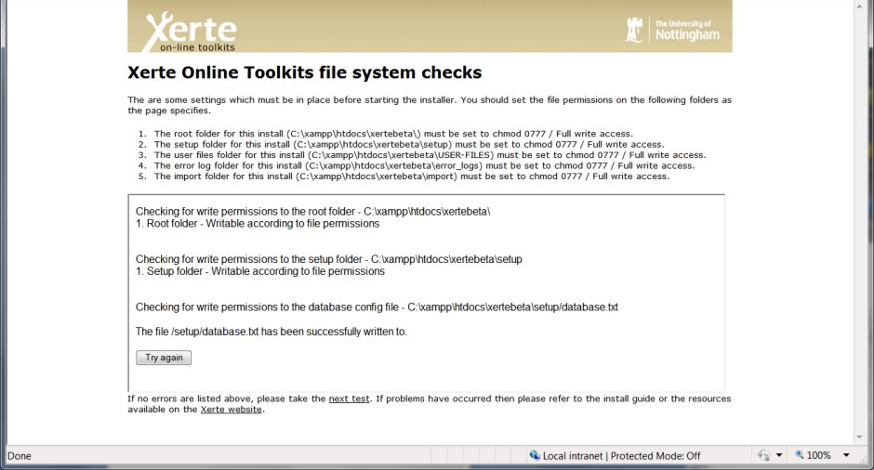
I get the following errors during the php module test:
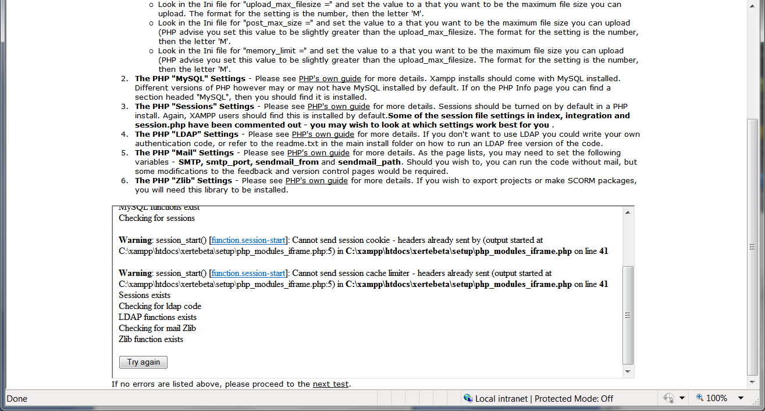
If I proceed to the installation I get the following error:
The sitedetails root_file_path query update sitedetails set root_file_path='C:\xampp\htdocs\xertebeta\' where site_id="1" has failed due to You have an error in your SQL syntax; check the manual that corresponds to your MySQL server version for the right syntax to use near ''C:\xampp\htdocs\xertebeta\' where site_id="1"' at line 1

Import path doesn’t get the correct slashes e.g. : C:xampphtdocsxertebetaimport/
And Root_file_path doesn’t get written at all.
Correcting these manually results in the following errors on both index.php and demo.php


