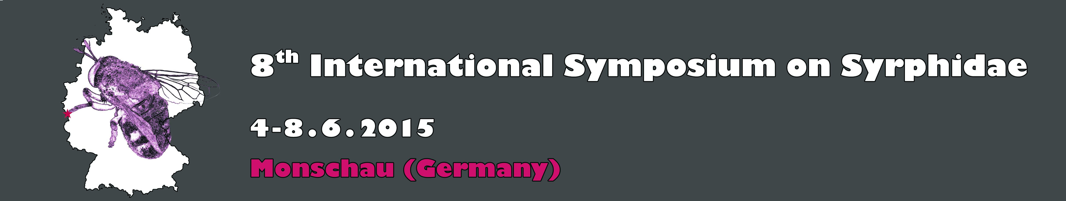

REGISTRATION FORM

To reserve a place at the symposium, please fill in this form and pay via wire-transfer (details below). Please mark with an X any option you like to take.

Surname (Family name) …………………...............……… First name …………….…………... Title ..................
Address ………………………………………………........................................................…………………………………
…………………………………................…………………………....................... Country .......................................
Email: ……………………………………………..

Student…....… …..

Registration fee: admission + delegate package = 45 € (incl. VAT)

Symposium Banquet (buffet menu) on Saturday (6.62015) evening. Cost 25 €…… …..

I am a vegetarian ………………… …..

Field excursion to Eifel surroundings on Monday 8.6.2015 (free)…...............….…… …..

Poster…… ….. Oral Presentation…… …..

I will need a letter of invitation…....… …..

I will require accommodation at the Carat Hotel (recommended)…....… …..
Single room (306 €)… ….. Double room (256,50 €)… ….. Triple room (if possible) (216 €)… …..

You can pay (only in Euros) the registration fee and the Symposium Banquet (deadline April 30th 2015) by bank transfer using the following information. Once paid, please send us the receipt of the transaction.

Bank name: Sparkasse Köln Bonn
IBAN: DE96 3705 0198 1931 1784 77 SWIFT (BIC): COLSDE33
Beneficiary: ZFMK Stiftung Subject: [your name] ISS8 fee

Please complete and return this form to:

Email: syrphidae8@gmail.com
Postal address: Ximo Mengual
Zoologisches Forschungsmuseum Alexander Koenig
Leibniz-Institut für Biodiversität der Tiere
Adenauerallee 160
D-53113 Bonn, Germany

