Thanksgiving, Christmas, and New Year cards with comic strips from the Our War newspaper in World War II

Thanksgiving Card:

This is back of card Fold here This is front of card Cut out here

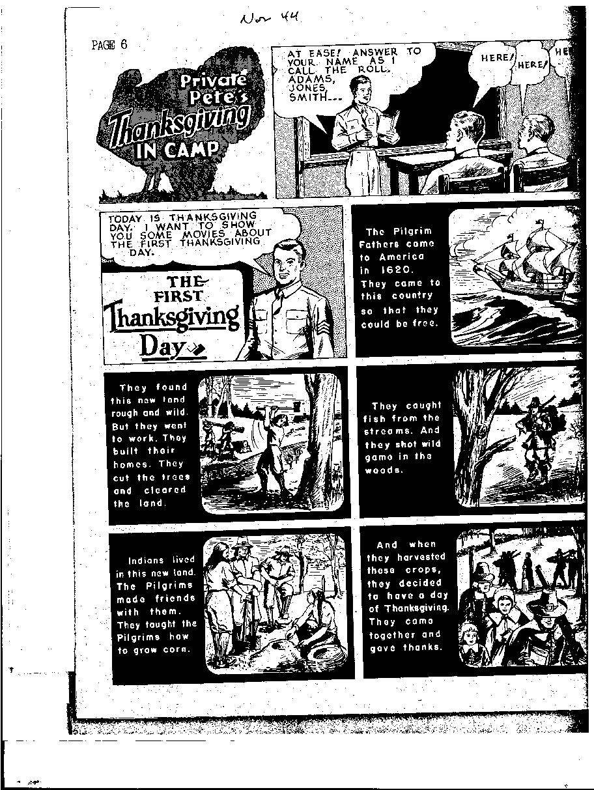
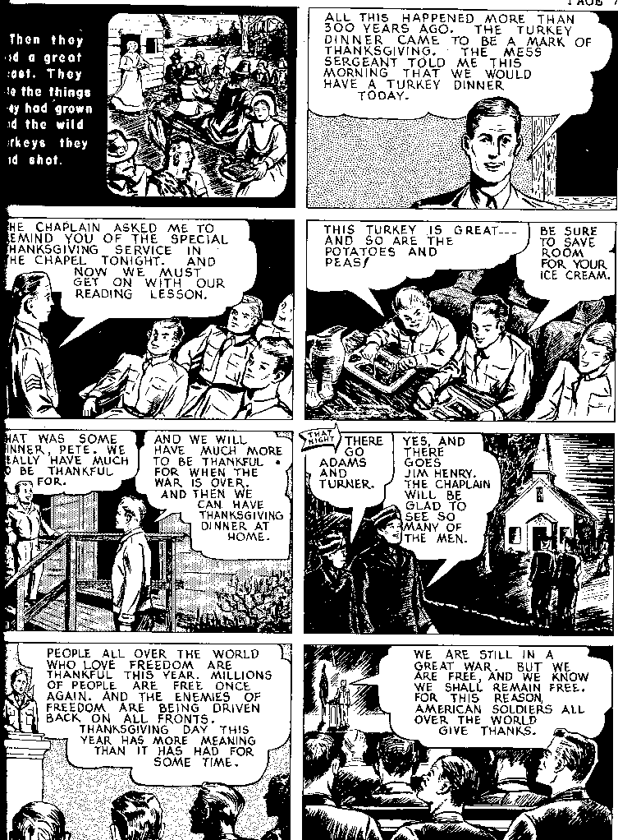
Support Adult Literacy Education!

Learning to read with Private Pete in World War II
During the war adult educators taught more than 250,000 soldiers to read in the Army’s Special Training Units. A newspaper called Our War featured a comic strip with a fictional literacy student named Private Pete and his buddy Daffy, both soldiers in the literacy program. This card is from the strip for November 1944.
[Crafted by Tom Sticht, 2017]

Cut out

After you cut out the card and fold the card so that the strip is on the front and the message about Learning to read with Private Pete is on the back, you can write your
Thanksgiving Day greetings inside.

Christmas Card:

This is back of card Fold here This is front of card Cut out here
Learning to read with Private Pete in World War II
During the war adult educators taught more than 250,000 soldiers to read in the Army’s Special Training Units. A newspaper called Our War featured a comic strip with a fictional literacy student named Private Pete and his buddy Daffy, both soldiers in the literacy program. This card is from the strip for December 1943.
[Crafted by Tom Sticht, 2017]

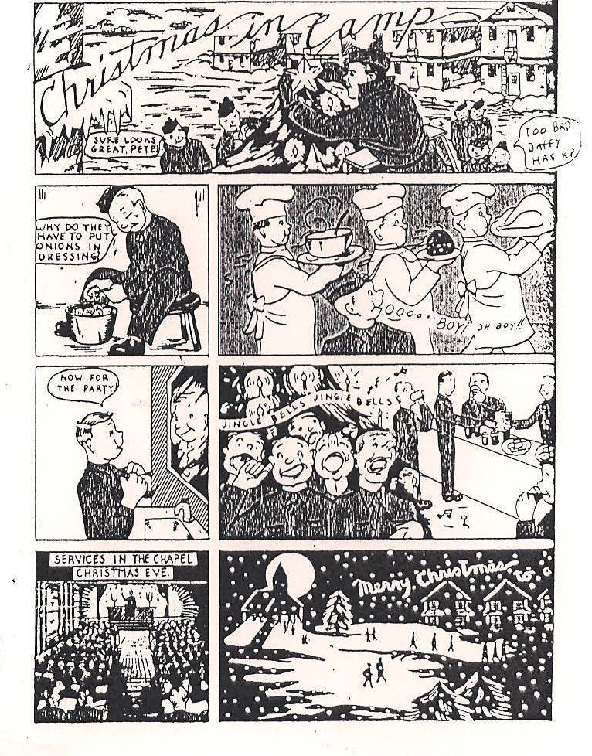

Support Adult Literacy Education!

Cut out

After you cut out the card and fold the card so that the strip is on the front and the message about Learning to read with Private Pete is on the back, you can write your Christmas greetings inside.

New Year Card:

This is back of card Fold here This is front of card Cut out here

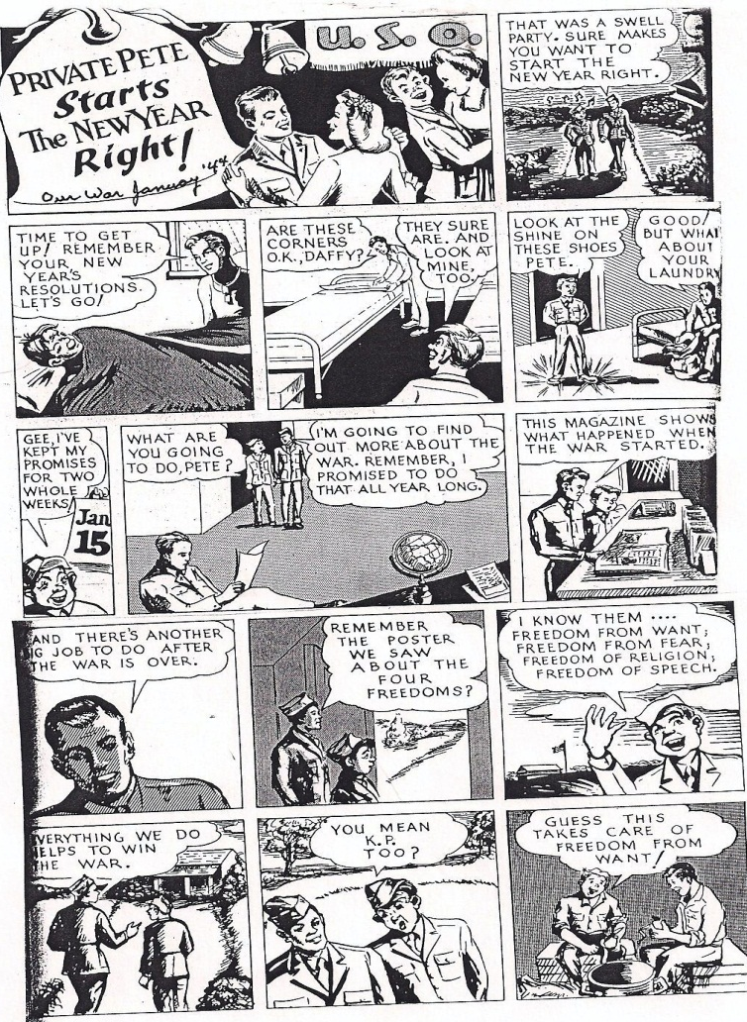
Support Adult Literacy Education!

Learning to read with Private Pete in World War II
During the war adult educators taught more than 250,000 soldiers to read in the Army’s Special Training Units. A newspaper called Our War featured a comic strip with a fictional literacy student named Private Pete and his buddy Daffy, both soldiers in the literacy program. This card is from the strip for January 1944.
[Crafted by Tom Sticht, 2017]

Cut out

After you cut out the card and fold the card so that the strip is on the front and the message about Learning to read with Private Pete is on the back, you can write your New Years greetings inside.

