ETHICS AND MATHEMATICS EDUCATION
The Good, the Bad and the Ugly

Paul Ernest, Editor

Introduction: The Good and the Bad
- Paul Ernest – The ‘Ethical Turn’ Reaches Mathematics Education

Philosophical foundations
- Ole Skovsmose - Mathematics is Indefinite: An Ethical Challenge
- Luis Radford - Self and Other
- Kelly Paton & Nathalie Sinclair - An ethico-onto-epistemology for mathematics education
- Dennis Müller - Situating “Ethics in Mathematics“ as a Philosophy of Mathematics Ethics Education

Re-envisoning ethics and mathematics
- Wolff-Michael Roth - Ethics in mathematics education: A foundation in the fullness of life
- Jean-François Maheux - Ethics and the Richness of Being in/for Mathematics Education Research
- Christopher H. Dubbs-For what is an ethical mathematics education research? On Foucauldian ethics as the conscious practice of freedom
- David Bowers, Merve N. Kursav, Emmanuel Nti-Asante & Katie Westby- (Re)constructing the heart of mathematics education: Ethics as first philosophy in research and praxis
- Yasmine Abtahi -The ethics of mathematics knowledge: imagination and empathy towards social and ecological solidarity
- Sikunder Ali - Ethical engagement with mathematics: how practices of mathematics create moral orders that govern modern souls under conditions of modernity

Ethical critique of mathematics education
- Paul Ernest -The Ethics of Authority and Control in Mathematics Education: From Naked Power to Hidden Ideology
- Alexander Moore -The Pathology of Mathematics Education
- Paul Dowling - Mathematics Education: Is it ethical?
- Darcy House-The-Death-of-Mathematics-A-Mythopoietic-Inquiry

Ethics and social justice in mathematics
- Grace A. Chen - Choosing Cruel Optimism: What Relational Ethics Offers Equitable Mathematics Education
- Colin Jakob Rittberg - Social Justice and the Objectivity of Mathematical Reasoning: a dilemma for policy makers

Ethics, teachers and the teaching of mathematics
- Lucy J Rycroft-Smith, Dennis Müller, Maurice Chiodo & Darren Macey - A useful ethics framework for mathematics teachers
- Anette Bagger - Ethical Dilemmas and Professional Judgement During National Assessment in Mathematics
- Kjellrun Hiis Hauge, Inger Elin Lilland, Suela Kacerja & Lisa Steffensen - Layers of ethical awareness – mathematics teachers’ concerns on including socio-political issues

Ethical content in the teaching and learning of mathematics
- Lovisa Sumpter, Maria Hedefalk, Peter Markkanen & Helena Eriksson - Ethical reasoning as part of mathematical modelling: young children’s work with sharing and division
- Catherine Buell & Victor I Piercey - Changing the Dialogue: Teaching Ethically-Valued Content and Teaching Ethically
- Deniz Sarikaya - A plea for research-based teaching in mathematics education (due to ethical reasons)

Afterword – The Ugly
- Alexandre Pais – The Garden of Ethics

Overview
- This is the first volume in mathematics education dedicated solely to Ethics
- Presents an emergent field of research within mathematics education (and mathematics)
- Extends across theory, critique and classroom practices in mathematics education
- Includes valuable contributions from the well-known international researchers in the field

About this book
This edited volume is an inquiry into the ethics of mathematics education, and to a lesser extent, the ethics of mathematics. The imposition of mathematics for all raises questions of ethics. What are the ethics of teaching school mathematics? What are the costs as well as the benefits? What are the ethical issues raised by the official aims of mathematics teaching, the planned curriculum, the pedagogies employed in school and college mathematics and the assessment systems? These questions are addressed in the book as well as what systems of ethics we might use. The volume ventures into a burgeoning new field. It offers a unique set of investigations, both theoretical and in terms of practices. It announces the ethics of mathematics education as a new subfield of research and includes valuable contributions from many of the best-known researchers in mathematics education; additionally, it is a valuable resource for students, teachers and researchers in the field. This is an enduring and classic source book in the field. From the wisdom of leading scholars to the little heard voices of students, this collection offers the reader many striking new insights into the ethics of mathematics and education.

SPRINGER, 2024
- Hardcover ISBN978-3-031-58682-8 Published: 11 June 2024
- Softcover ISBN978-3-031-58685-9 Due: 12 July 2024
- eBook ISBN978-3-031-58683-5 Published: 10 June 2024
- Number of Pages VII+ 521

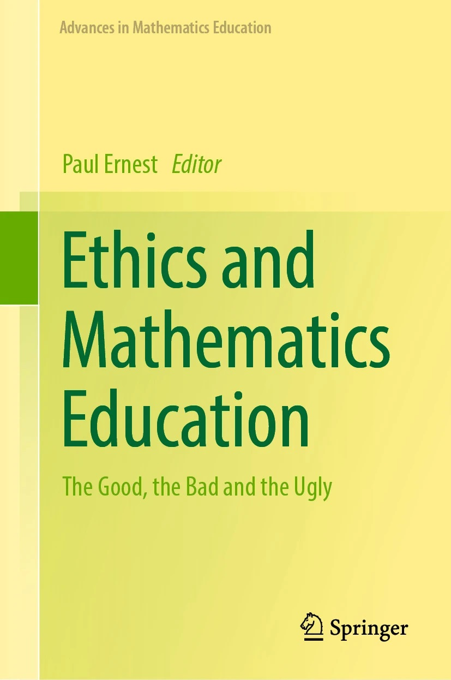

THE ‘ETHICAL TURN’ REACHES MATHEMATICS EDUCATION

Paul Ernest

University of Exeter, UK

ABSTRACT

The widespread ‘ethical turn’ in philosophy, the humanities and social sciences has left the research field of mathematics education behind. Mathematics education, especially its central activities of teaching and learning mathematics, is thoroughly entangled with issues of ethics and justice. While there are many books on social justice and mathematics education, no dedicated volume on the ethics of mathematics and education has yet been published. This book aims to fill this gap. Perhaps this lack is no accidental oversight, for mathematics holds itself aloof from ethics claiming that as it is objective it is beyond good and evil. Given mathematics education’s birth from, and continued identification with mathematics itself, it is no surprise that it is one of the last bastions to wake up to the relevance and importance of ethics. This book explores the philosophical foundations of ethics and mathematics, offers a re-envisioning of what we mean by ethics and then provides an ethical critique of mathematics education from multiple perspectives. The common ground shared by ethics and social justice in mathematics is explored, as is the ethics of teacher and learner perspectives. After looking at ethical content in the teaching and learning of mathematics the book concludes with a critical self-examination of this whole inquiry, questioning the ‘ethics of ethics’ and what we might mean by the ‘good’.

Keywords: ‘ethical turn’; ethics in mathematics and mathematics education; philosophical foundations of ethics; teacher and learner perspectives; the ethics of authority; social justice; ethical content in mathematics; ethical critique of mathematics education; the good; the ‘ethics of ethics’.

NEW BOOK ANNOUNCEMENT

ETHICS AND MATHEMATICS EDUCATION
The Good, the Bad and the Ugly

Paul Ernest, Editor

There will be an online launch of the book courtesy of
The Critical Philosophical and Psychoanalytic Institute for Mathematics Education (CPPI-ME).
Watch the website for the announcement of how to join

See attachment for details of contents

Or follow link:
https://link.springer.com/book/10.1007/978-3-031-58683-5

Overview
- This is the book in mathematics education dedicated solely to ethics
- Presents an emergent field of research within mathematics education (and mathematics)
- Extends across theory, critique and classroom practices in mathematics education
- Includes valuable contributions from the well-known international researchers in the field

About this book
This edited volume is an inquiry into the ethics of mathematics education, and to a lesser extent, the ethics of mathematics. The imposition of mathematics for all raises questions of ethics. What are the ethics of teaching school mathematics? What are the costs as well as the benefits? What are the ethical issues raised by the official aims of mathematics teaching, the planned curriculum, the pedagogies employed in school and college mathematics and the assessment systems? These questions are addressed in the book as well as what systems of ethics we might use. The volume ventures into a burgeoning new field. It offers a unique set of investigations, both theoretical and in terms of practices. It announces the ethics of mathematics education as a new subfield of research and includes valuable contributions from many of the best-known researchers in mathematics education; additionally, it is a valuable resource for students, teachers and researchers in the field. This is an enduring and classic source book in the field. From the wisdom of leading scholars to the little heard voices of students, this collection offers the reader many striking new insights into the ethics of mathematics and education.

SPRINGER, 2024
- Hardcover ISBN978-3-031-58682-8 Published: 11 June 2024
- Softcover ISBN978-3-031-58685-9 Due: 12 July 2024
- eBook ISBN978-3-031-58683-5 Published: 10 June 2024
- Number of Pages VII+ 521

