News. April to November 2024 – Tony Day

- Congratulations

Jacob Betts (UEA), jointly supervised by Linda Troeberg (UEA) and Tony Day, was awarded his PhD in August 2024. Jacob’s thesis was on Molecular mechanisms of TIMP-3 turnover in Sorsby Fundus Dystrophy.

- (Virtual) Conferences / Seminars / Training courses

Tony Day attended the Osteoarthritis Research Society International (OARSI) 2024 World Congress on Osteoarthritis, Vienna, Austria, 18-21 April. Jenny Scott (from Tony’s lab) presented a poster: New method for quantitation of TSG-6 in synovial fluid of osteoarthritis patients.

Tony Day (along with other members of Link Biologics) attended the European Dry Eye Society (EuDES) Congress, Madrid, Spain, 21–24 June, 2024.

Tony Day was a Discussion Leader at the Gordon Research Conference on Proteoglycans, 7-12 July 2024, Andover, NH, USA. Rebecca Dodd presented a talk and poster at the Gordon Research Seminar on Proteoglycans, 6-7 July 2024, and at the Gordon Research Conference on Proteoglycans, 7-12 July 2024, Andover, NH, USA. Title: IL-13 as a modulator of the hyaluronan matrix during lung inflammation and injury.

- Publications / Grants

Grants
NIH R01 (1R01HL171283-01), £1,992,914 15/08/24-14/08/28: The role of IL-13 in COVID-19 severity. William A. Petri (University of Virginia), Judith E. Allen and Tony Day co-PIs.
NIH R01 (5R01GM134226-06), ~£880,000, 01/09/24-31/08/28: Development of solid-state nanopore technology for improved glycosaminoglycan analysis. Adam Hall PI (Wake Forrest University Health Sciences, USA); Paul DeAngelis (University of Oklahoma Health Sciences Center) and Tony Day, co-Is.
Wellcome Discovery Award (304200/Z/23/Z), £3,379,143, 01/01/25-31/12/30: Immune regulation of the hyaluronan matrix in the lung during infection, injury and repair. Judith E. Allen PI; Tony Day, Tracy Hussell, Tara Sutherland and William A. Petri co-applicants.

Publications
Dodd, R.J., Blundell, C.D., Sattelle, B.M., Enghild, J.J., Milner, C.M. & Day, A.J. (2024) Chemical modification of hyaluronan oligosaccharides differentially modulates hyaluronan-hyaladherin interactions. J. Biol. Chem., in press. Published as a Paper in Press on 9 August 2024.
Shah, A., Zhang, X., Snee, M., Lockhart-Cairns, M.P., Levy, C.W., Jowitt, T.A., Birchenough, H.L., Dean, L., Collins, R., Dodd, R.J., Roberts, A.R.E., Enghild, J.J., Mantovani, A., Fontana, J., Baldock, C., Inforzato, A., Richter, R.P. & Day, A.J. (2024) The structural organisation of pentraxin-3 and its interactions with heavy chains of inter-α-inhibitor regulate crosslinking of the hyaluronan matrix. Published as a preprint at BioRxiv on 15 August 2024: https://biorxiv.org/cgi/content/short/2024.08.14.607909v1.
Scott, J., Dong, Y., Yin, J., Dodd, R.J., Kouvatsos, N., Drummond, S.P., Anand, S., Biant, L., Milner, C.M. & Day, A.J. (2024) A novel method to quantify TSG-6 protein levels in synovial fluid from osteoarthritis patients. Proteoglycan Research 2, e70003. http://dx.doi.org/10.1002/pgr2.70003
Day, A.J. (2024) Hyaluronan-protein interactions: Lilliput revisited. Proteoglycan Research, in press. Published online on 7th November 2024: https://doi.org/10.1002/pgr2.70007
Dodd, R.J., Allen, J.E. & Day, A.J. (2024) Hyaluronan in COVID-19: a matrix for understanding lung disease (invited commentary). mBio, in press.
Moran, M.M., Li, J., Day, A.J., Naqib, A., Green, S.J., Sumner, D.R., Plaas, A. Evidence of silencing of intestinal inflammatory and immune transcripts following induction of joint inflammation. Published as a preprint on BioRxiv on 17 October, 2024: https://www.biorxiv.org/content/10.1101/2024.10.17.618923v1
Dodd, R.J., Moffatt, D., Vachiteva, M., Parkinson, E.J., Chan, H.K.B., Day, A.J., Allen, J.E. & Sutherland, T. IL-13 modulates the hyaluronan matrix following injury by the lung migrating nematode Nippostrongylus brasiliensis. Proteoglycan Research, in press.

- Other News

Tony Day (and Caroline Milner) have written a blog for Translation Manchester describing their translational journey on the development of Link_TSG6 and the spinning out of Link Biologics: https://www.translation.manchester.ac.uk/2024/06/26/success-stories-link-biologics/

- Extra-curricular Activities

In September Tony Day (and Caroline Milner) went on holiday to the Outer Hebrides. Pictured below the journey from Mallaig to South Uist, Luskentyre beach (Harris) and Callanish (Lewis); photos © Tony Day 2024.

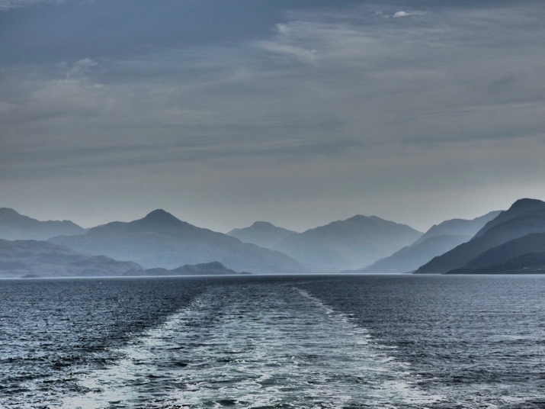

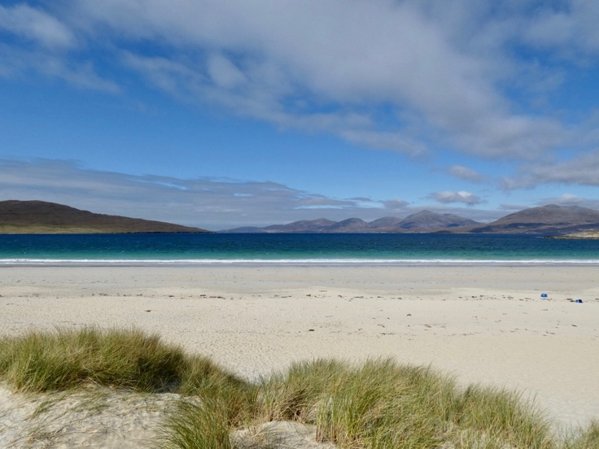

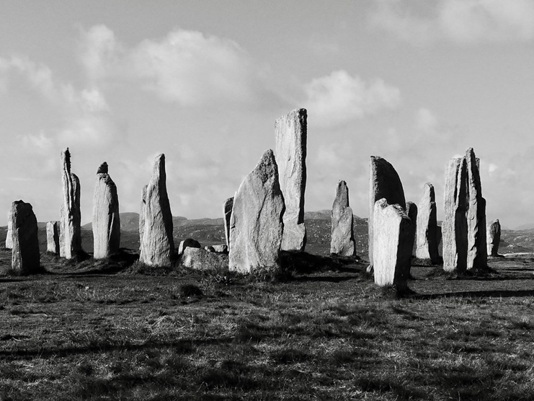

Tony Day has acquired yet another electric guitar!

